Willy Bars Instructions

Included Hardware
In addition to the 1up hardware, there are also additional carriage bolts that are 1-3/4” long in the ziplock bag. Use these instead of the 2” bolts supplied by 1up for a flush mount. The 2” hardware can be used with the 1up brackets if you want to mount 3 racks on the bars.
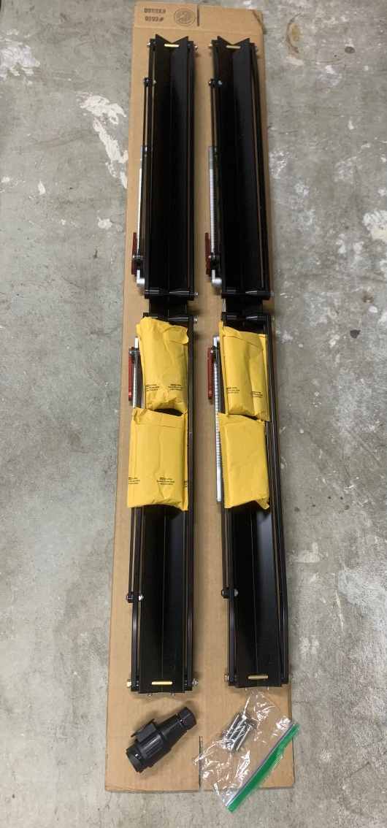

Bar Installation
- Retrieve the hook tool from the frunk. There is a tool sleeve under the right panel.
- Insert it into the slot in the two rear covers and pull firmly backwards.
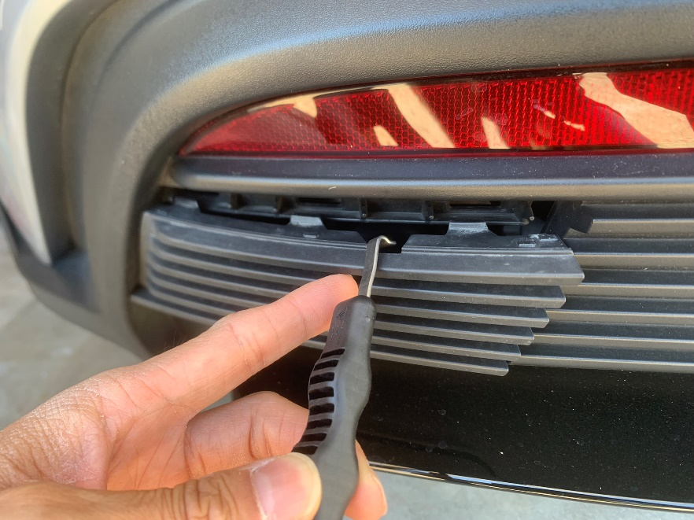
- The bars are inserted into the sockets and rotated to hold in place.
- The bars have a large hole and a small hole for the bike racks. The small hole should be facing up when rotated in place.
- Install the separately supplied 1-3/4” carriage bolts in the 1up trays. They will only go in from one side of the tray.
- Line up the carriage bolts on the bars and hand tighten the 1up supplied barrel nuts and steel washers from below. Hardware should look like this (bars omitted for visibility):
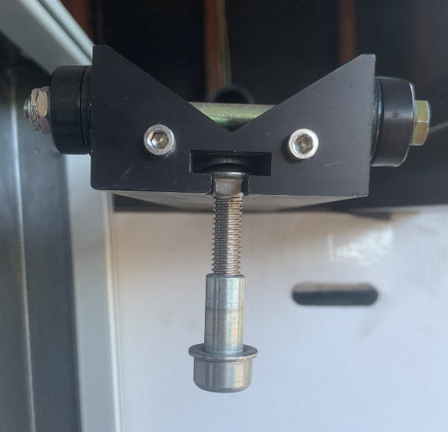
- Use the 1up supplied wrench to tighten the barrel nuts snugly. Should take about an 1/8-1/4 turn. Once assembled, it should look like this:
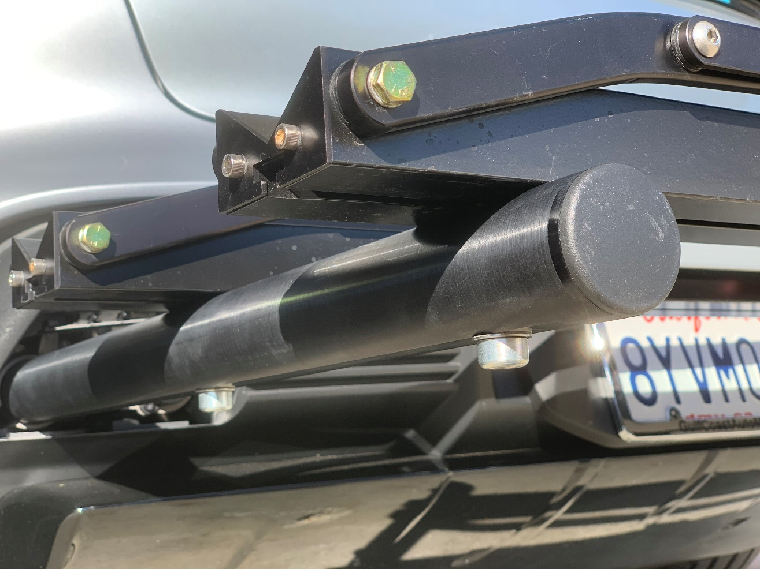

Trailer Plug
The trailer plug disables the key fob and center console power lift gate buttons to prevent accidental openings. The tailgate can still be opened with the button on the rear bumper, like normal. The rear park distance sensors are also disabled so there are no proximity warnings from the rear when in reverse. Lane Change Assist (LCA) is also disabled. Don’t forget the rack is extending out the back when reversing.
- Open the cover and insert the plug with the flat round face pointing down (pic 1).
- Rotate the flat round face clockwise 90deg and the plug will engage (pic 2).
- When installed correctly, the cover will sit flush on the round face of the plug.
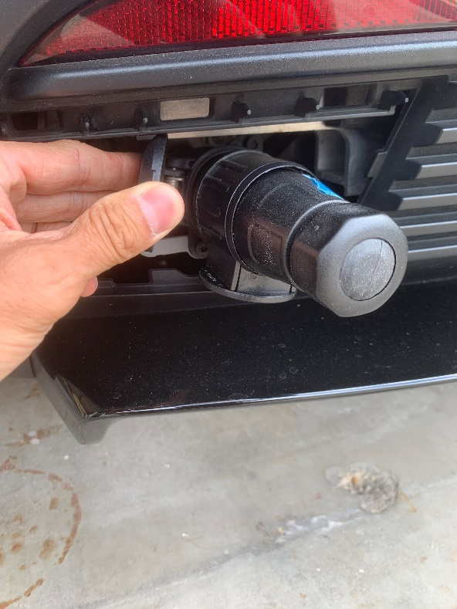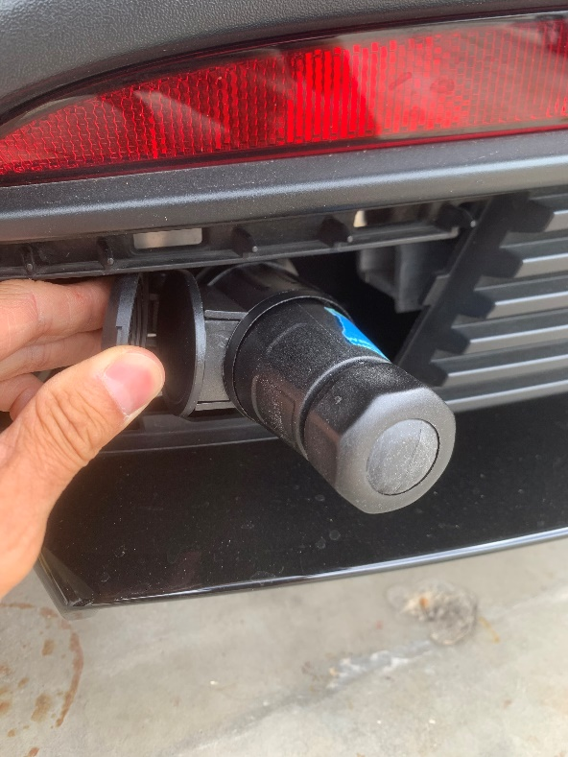
Pic 1 Pic 2
It is normal for the plug to get hot, max 60C/130F, when plugged in.
The plug pinouts are a standard 13-pin European trailer style. In case you want to wire lights to it.


